Daniel Prusinski

412

Appendix 1 for Assignment 5 – Mathematical Programming

Output 1: Metadata

print(summary(call.center.input.data))

vru.line call_id customer_id priority

Length:33344 Min. : 1410 Min. :0.000e+00 Min. :0.0000

Class :character 1st Qu.:15108 1st Qu.:0.000e+00 1st Qu.:0.0000

Mode :character Median :31511 Median :0.000e+00 Median :0.0000

Mean :27291 Mean :3.139e+08 Mean :0.6856

3rd Qu.:35330 3rd Qu.:2.813e+07 3rd Qu.:2.0000

Max. :37369 Max. :7.240e+11 Max. :2.0000

type date vru_entry vru_exit

Length:33344 Length:33344 Length:33344 Length:33344

Class :character Class :character Class :character Class :character

Mode :character Mode :character Mode :character Mode :character

vru_time q_start q_exit q_time

Min. :-192.00 Length:33344 Length:33344 Min. : 0.00

1st Qu.: 6.00 Class :character Class :character 1st Qu.: 0.00

Median : 9.00 Mode :character Mode :character Median : 9.00

Mean : 10.46 Mean : 41.79

3rd Qu.: 11.00 3rd Qu.: 57.00

Max. :1860.00 Max. :908.00

outcome ser_start ser_exit ser_time

AGENT :27162 Length:33344 Length:33344 Min. : 0.0

HANG : 5904 Class :character Class :character 1st Qu.: 15.0

PHANTOM: 278 Mode :character Mode :character Median : 80.0

Mean : 144.3

3rd Qu.: 180.0

Max. :4264.0

server

Length:33344

Class :character

Mode :character

Output 2: Time Shifts

print(str(bank.shifts.data.frame))

'data.frame': 24 obs. of 10 variables:

$ Hour : int 1 2 3 4 5 6 7 8 9 10 ...

$ StartTime: Factor w/ 24 levels "10am","10pm",..: 23 5 7 9 11 13 15 17 19 21 ...

$ Shift1 : int 1 1 1 1 1 1 0 0 0 0 ...

$ Shift2 : int 0 0 0 0 0 0 1 1 1 1 ...

$ Shift3 : int 0 0 0 0 0 0 0 0 1 1 ...

$ Shift4 : int 0 0 0 0 0 0 0 0 0 0 ...

$ Shift5 : int 0 0 0 0 0 0 0 0 0 0 ...

$ Shift6 : int 0 0 0 0 0 0 0 0 0 0 ...

$ Shift7 : int 0 0 0 0 0 0 0 0 0 0 ...

$ Shift8 : int 0 0 0 0 0 0 0 0 0 0 ...

NULL

Output 3: Tuesday Call Center

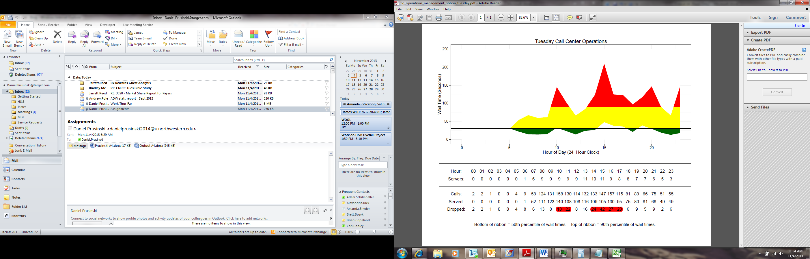

Output 4: Current Arrived/Served

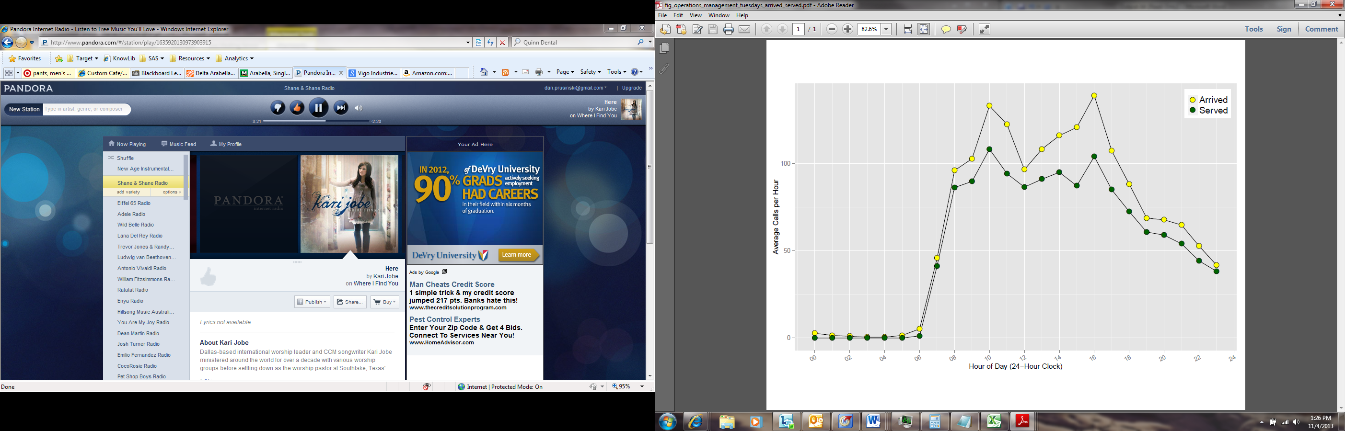

Output 5: Optimum Solution

